Note Seven

* Omitted variable bias
  + u that influence Y but not included as regressors
  + Can lead to bias
* Omitted factor “Z”
  + A determinant of Y
  + **Correlated with regressor X → corr(Z, X) ≠ 0**
* If both conditions are met, **biased**

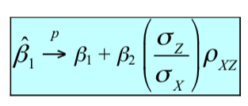

* + How to overcome it
    - Run randomized controlled experiment
    - Use a regression in which the omitted variable is no longer omitted
* Multiple regression model
  + Interpretation
    - Holding other factors constant, effect of Xi
    - 
* Adjusted R2
* Assumption
  + 1
    - Conditional mean of u given the included X is 0
  + 2
    - 
  + 3
    - Large outliers are rare
  + 4
    - No perfect multicollinearity
      * When one of the regressors is an exact linear combination of other regressors
* Dummy variable trap
  + Occur when we have a lot of dummy variables
  + There are multiple categories and every observation falls in one and only one category
  + Sum will be 1 ⇒ trap
    - If there is a trap
    - OLS cannot be estimated
    - STATA returns an error message
  + Solution
    - Omit one of the group dummies
    - Omit the intercept
* Imperfect multicollinearity
  + Two or more regressors are very highly correlated
  + Unless the correlation is exactly +/- 1, that collinearity is imperfect